Practical 5 : Triggers

Learning objectives:

- Overview of triggers
- Types of triggers
- Creating and modifying triggers
- Drop, enable and disable triggers

References
PL/SQL Language Reference https://docs.oracle.com/en/database/oracle/oracle-database/18/lnpls/database-pl-sql-language-reference.pdf

https://docs.oracle.com/en/database/oracle/oracle-database/19/tdddg/using-triggers.html

Syntax of trigger

CREATE OR REPLACE TRIGGER trigger_name
[BEFORE / AFTER]
[DELETE / INSERT / UPDATE OF column_name]
ON table_name
[FOR EACH ROW]
[WHEN (condition)]
[DECLARE]
[variable_name data type[:=initial_value]]
BEGIN
PL/SQL instructions;
END;
/
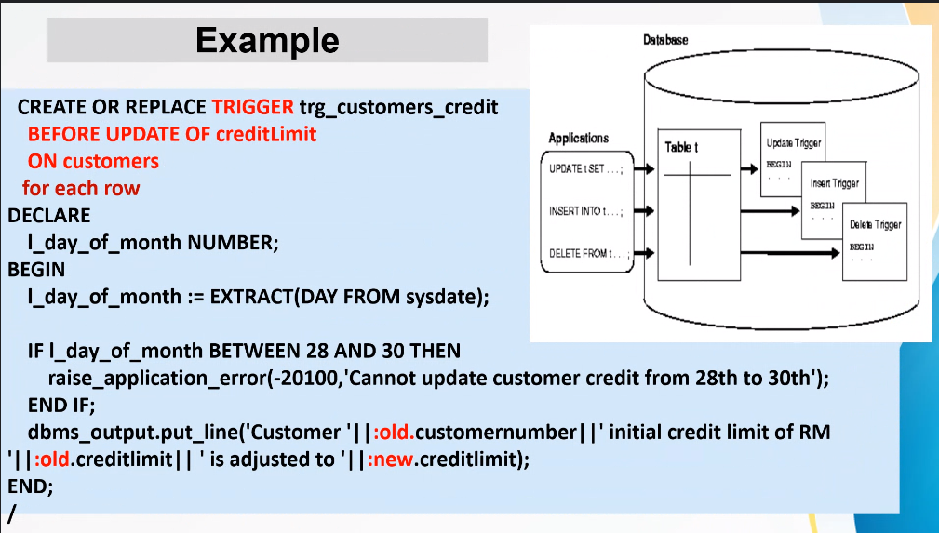

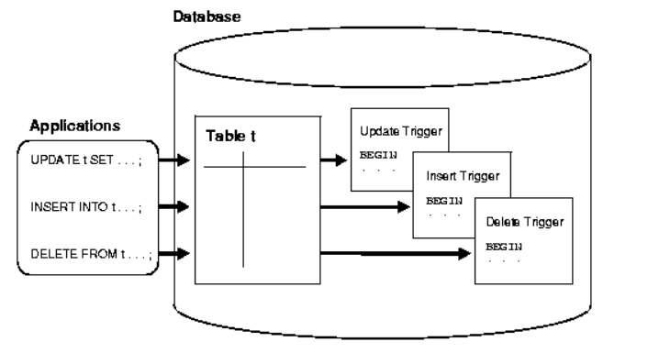
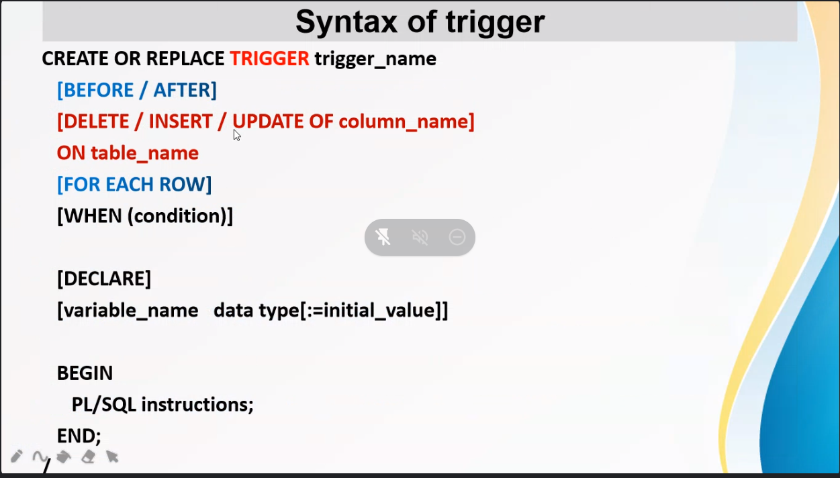
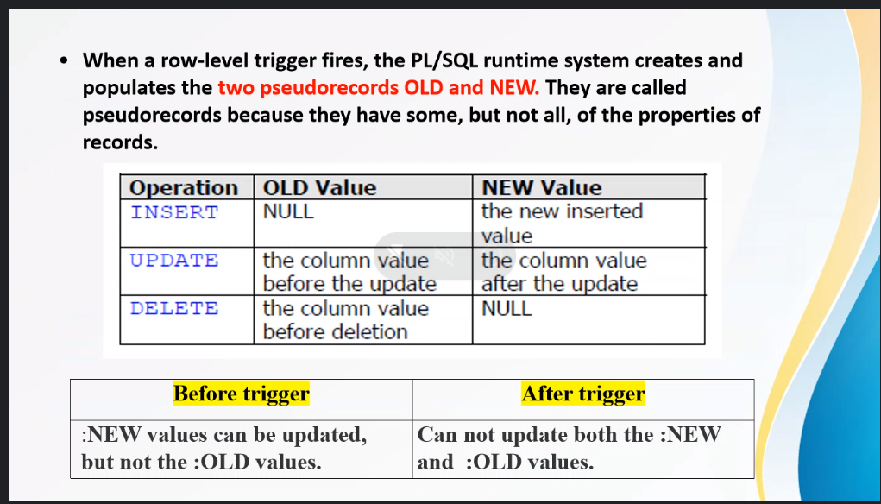

Consider this new scenario:
- We now need to store four more details in the ORDERS table, whenever an order is made.
orderAmount, discount, totalDiscount and finalTotal

- We also need to accumulate the monthly spending by each customers.
(discount is defined as a percent, i.e. 5% to a maximum of 50%).

To capture the orderAmount, totalDiscount and finalTotal we need to modify the existing ORDERS table:
alter table orders
add (orderAmount Number(7,2) Default 0.00,
discount Number(2,2) Default 0.05,
totalDiscount Number(7,2) Default 0.00,
finalTotal Number(7,2) Default 0.00);

Check the new structure and data for correctness:
SQL>desc Orders

SQL>Select orderNumber, orderAmount, discount, totalDiscount,
finalTotal from Orders;

orderAmount, totalDiscount and finalTotal can only be calculated after we insert the necessary data into the ORDERDETAILS.
For each order detail, we need to calculate:
orderAmount= orderDetails.priceEach * orderDetails.quantityOrdered
totalDiscount = orderAmount * orders.Discount
finalTotal = orderAmount - totalDiscount

Every time a new record is inserted into OrderDetails table, the above calculations should be accumulated automatically to the same OrderNumber record in the ORDERS table.

As we accumulate the amounts of the ORDERS table, we should also accumulate the amount spent by each customer in a month automatically

Run the cusMonth.sql to create the CUSTOMERS_MONTHLY table.
create table CUSTOMERS_MONTHLY
( customerNumber number(11) NOT NULL,
yearNo number(4) NOT NULL,
monthNo number(2) NOT NULL,
monthly_Amount number(9,2),
primary key (customerNumber, yearNo,monthNo)
);

To demonstrate the workings of the TRIGGER, we need to remove the ORDERDETAILS records and re-insert them and as each record is inserted, the DBMS will automatically do the necessary calculations.

We will need to create two triggers that will do the following:
- Monitor any insert into the ORDERDETAILS table. After an insert, automatically calculate and update the ORDERS table on the
OrderAmount, TotalDiscount and FinalTotal columns

- Monitor any updates of the column FinalTotal on the ORDERS table. When this column is updated, the customer’s monthly spending should also be updated.

General use of TRIGGERS
- Triggers are to “monitor” changes to the database
- Take the appropriate “action” so that important data (and information) are not lost due to update and delete.
- Most of the time, triggers will have instructions to store important data/information in a log or audit file.
- Triggers can also stop a DML statement such as INSERT, UPDATE, DELETE from executing by invoking a system error (use a BEFORE trigger)
  - i.e. use RAISE_APPLICATION_ERROR
  - If RAISE_APPLICATION_ERROR is used on AFTER trigger, the effect of the DML statement has taken place and may need to ROLLBACK

Task
- Remove the ORDERDETAILS records
Delete ORDERDETAILS;

- Create the triggers.
Start c:\trig1
Start c:\trig2

Note:
trig1.sql will automatically update orderAmount,totalDiscount and finalTotal on the ORDERS table every time a record is successfully inserted into the ORDERDETAILS table.

CREATE OR REPLACE TRIGGER TRG_UPT_ORDERS_AMT
AFTER INSERT ON orderDetails
FOR EACH ROW
DECLARE
v_OrderAmount NUMBER := 0.00;
v_TotalDiscount NUMBER := 0.00;
v_FinalTotal NUMBER := 0.00;
v_discount number(2,2);

BEGIN
select discount into v_discount
from Orders
where orderNumber = :new.orderNumber;

v_OrderAmount := :new.priceEach * :new.quantityOrdered;
v_TotalDiscount := ROUND( v_OrderAmount * v_discount,2);
v_FinalTotal := v_OrderAmount - v_TotalDiscount;

UPDATE ORDERS
SET OrderAmount = OrderAmount + v_OrderAmount,
TotalDiscount = TotalDiscount + v_TotalDiscount,
FinalTotal = FinalTotal + v_FinalTotal
WHERE orderNumber = :new.orderNumber;
END;
/
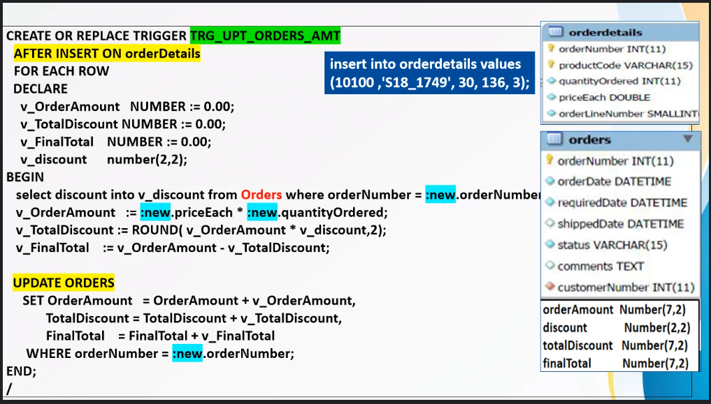
Note:
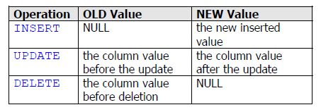
trig2.sql will automatically update the customer’s monthly spending every time there is an update of finalTotal on the ORDERS table.
CREATE OR REPLACE TRIGGER TRG_UPT_CUST_MONTHLY
AFTER UPDATE OF FinalTotal ON Orders
FOR EACH ROW
DECLARE
v_custNum CUSTOMERS.CUSTOMERNUMBER%TYPE;

BEGIN
Select customerNumber into v_custNum
From CUSTOMERS_MONTHLY
Where customerNumber = :new.customerNumber AND
YearNo = EXTRACT(Year From(:new.OrderDate)) AND
MonthNo = EXTRACT(Month From(:new.OrderDate));

IF SQL%FOUND THEN
UPDATE CUSTOMERS_MONTHLY
SET Monthly_Amount = Monthly_Amount + :new.FinalTotal - :old.FinalTotal
WHERE customerNumber = :new.customerNumber AND
YearNo = EXTRACT(Year From(:new.OrderDate)) AND
MonthNo = EXTRACT(Month From(:new.OrderDate));
END IF;

EXCEPTION
WHEN NO_DATA_FOUND THEN
INSERT INTO CUSTOMERS_MONTHLY VALUES
(:new.customerNumber,EXTRACT(Year From(:new.OrderDate)),
EXTRACT(Month From(:new.OrderDate)),:new.FinalTotal);
END;
/
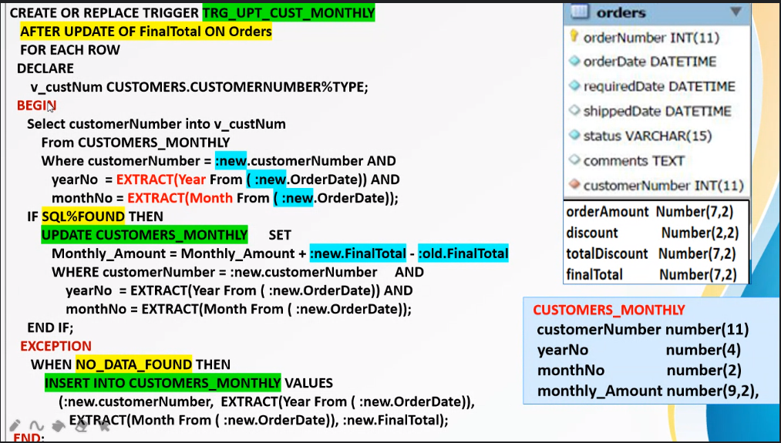
- To fire the trigger, insert one orderDetails record.
insert into orderdetails values(10100,'S18_1749',30,136,3);

- Check the updates.
Select orderNumber, OrderAmount, TotalDiscount, FinalTotal
from Orders where orderNumber = 10100;

Select * from orderDetails;

Select * from customers_monthly;

- Insert two more test data.
insert into orderdetails values(10100,'S18_2248',50,55.09,2);
insert into orderdetails values(10100,'S18_4409',22,75.46,4);

- Check the updates.

- Remove all the changes done to the database.
ROLLBACK;

Select orderNumber, OrderAmount, TotalDiscount, FinalTotal
from Orders where orderNumber = 10100;

Select * from orderDetails;

Select * from customers_monthly;

- Execute the script Insert_Orderdetails.txt to re-insert data into the orderDetails table. As each record is inserted, the correct amount will be accumulated to the respective ORDERS and CUSTOMERS_MONTHLY records.

- Check the updates.

In Practical 3, there is a procedure PRC_PRICE_INCR(xxx) that accepts an input ProductCode and updates the price of that product. The procedure will also write a record to the Price_Audit table, used to keep track of the changes to the product.

However, a record will only be written to the Price_Audit table if the user executes the PRC_PRICE_INCR(xxx) procedure. If an update to the product price was done by other means (e.g. user type the update DML directly or run another procedure to update), then the changes will not be recorded for future reference.

Task
a. Create a trigger to automatically record the price changes of any product:

CREATE OR REPLACE TRIGGER TRG_INSERT_Price_Audit
AFTER UPDATE OF MSRP ON Products
FOR EACH ROW
BEGIN
INSERT INTO Price_Audit VALUES
(:new.productCode, :new.productName,
:old.MSRP, :new.MSRP, USER, SYSDATE);
END;
/

Once this trigger is created (and enabled), all changes to MSRP in PRODUCTS table will be automatically recorded into the Price_Audit table without any further intervention from the user.

b. Modify the PRC_PRICE_INCR(xxx) procedure by removing the code that does the INSERT to the Price_Audit table.

c. Execute PRC_PRICE_INCR(xxx)with sample test data and check the Price_Audit table for updated rows.

Fire Once Trigger/ Statement-level Trigger

The trigger examples given above will activate for every row of record being manipulated (such triggers are called as row-level triggers). We may also create a trigger that only fire once even though the INSERT, UPDATE, DELETE events may have manipulated more than one row of records.

Consider the following:
We now want to perform a simple tracking of the EMPLOYEES table. We would like to record the number of INSERT,UPDATE,DELETE activities that is performed on the EMPLOYEES table. We do not need to know the exact number of records manipulated, we just want to know if some DML activities are being performed.

Firstly, create the Employees_audit table:
CREATE TABLE Employees_Audit
( TransDate Date,
No_of_Insert Number(3),
No_of_Update Number(3),
No_of_Delete Number(3)
);

Next, examine and create the trig3.sql code. This is an example of a fire once trigger.
CREATE OR REPLACE TRIGGER Track_Employees
BEFORE INSERT OR
UPDATE OR
DELETE
ON employees
DECLARE
v_date date;

BEGIN
select TransDate into v_date
from Employees_Audit
where to_char(TransDate,'DD-MON-YY') = to_char(SYSDATE,'DD-MON-YY');
-- check if there is already a record for today ---

if SQL%FOUND THEN
CASE
WHEN INSERTING THEN
UPDATE Employees_AUDIT
SET No_Of_Insert = No_Of_Insert + 1
where to_char(TransDate,'DD-MON-YY') = to_char(SYSDATE,'DD-MON-YY');
WHEN UPDATING THEN
UPDATE Employees_AUDIT
SET No_Of_Update = No_Of_Update + 1
where to_char(TransDate,'DD-MON-YY') = to_char(SYSDATE,'DD-MON-YY');
WHEN DELETING THEN
UPDATE Employees_AUDIT
SET No_Of_Delete = No_Of_Delete + 1
where to_char(TransDate,'DD-MON-YY') = to_char(SYSDATE,'DD-MON-YY');
END CASE;
end if;

exception
when no_data_found then
CASE
WHEN INSERTING THEN
INSERT INTO Employees_AUDIT VALUES(sysdate,1,0,0);
WHEN UPDATING THEN
INSERT INTO Employees_AUDIT VALUES(sysdate,0,1,0);
WHEN DELETING THEN
INSERT INTO Employees_AUDIT VALUES(sysdate,0,0,1);
END CASE;
END;
/

What is the difference between a row-level trigger and a statement-level trigger?

- If you perform an update that will affect 10 rows, a statement level trigger will fire once and a row level trigger will fire 10 times.
- A statement level trigger does not have access to individual column values. A row level trigger does have access to column values.

INSTEAD OF Trigger for Updating a View

Recall that a complex view cannot be updated. For example, consider the following requirement to show each employee’s reporting line:

Select employeeNumber, lastName, firstName, jobTitle, ReportsTo
From employees
Order by ReportsTO;

What if we also want the names of the manager to be displayed?

The following view will list employees that manages other employees.

CREATE OR REPLACE VIEW MANAGER_VIEW AS
select distinct(Wkr.reportsTo) AS ManagerID, Mgr.lastname,
Mgr.firstname, Mgr.jobTitle
from employees Mgr, employees Wkr
where (Wkr.reportsTo = Mgr.employeeNumber);

If you need to change the title of empid (5) to ‘Senior Sales Manager’, the following is the DML

update manager_view
set jobTitle = 'Senior Sales Rep'
where ManagerID = 1621;

What is the error message?

We will use a INSTEAD OF trigger to update a complex view:

CREATE OR REPLACE TRIGGER update_mgr_view
INSTEAD OF UPDATE ON manager_view
FOR EACH ROW
BEGIN
-- allow the following updates to the underlying employees table
UPDATE employees
SET JobTitle = :NEW.jobTitle
WHERE employeeNumber = :OLD.ManagerId;
END;
/

Disabling/enabling a Specific Trigger
ALTER TRIGGER Track_Employees DISABLE/ENABLE;

Disabling All Triggers on a Table
ALTER TABLE products DISABLE ALL TRIGGERS;

Enabling All Triggers for a Table
ALTER TABLE products ENABLE ALL TRIGGERS;

When a table is removed using the DROP TABLE, all triggers associated with the table will also be dropped.

Exercises

    - Add a new column to the CUSTOMERS table to store each customer’s cumulative purchase to date. Create the appropriate trigger to accumulate this amount automatically.
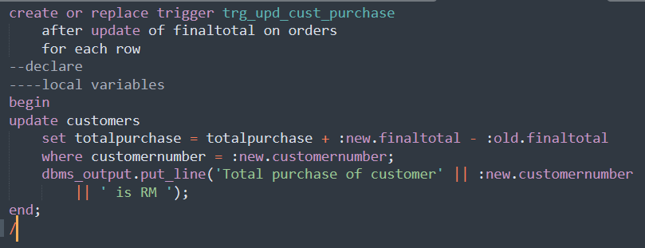
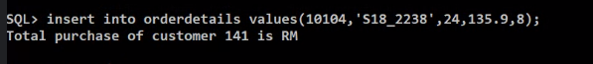
    - Add a total_units_sold column to the PRODUCTS table. Create a trigger to accumulate the total units sold for each product.

    - Create a trigger name trg_upd_prodqty that will automatically update the product quantityInStock each time an order transaction is processed.

    - Create an audit table to keep track of the relevant product information and audit information for DML events performed on the PRODUCTS records. Then, create a trigger that will insert into the audit table for the monitored DML events [You decide what DML events to monitor.]

    - Modify the EMPLOYEES table to satisfy the following requirements:
When an employee record is created, the HireDate will automatically be assigned the system’s current date. Furthermore, the employee must be at least 18 years old at the time of hire. Create a trigger to perform this task. If this age restriction is not followed, the record cannot be inserted.
[ Note 1 : Use RAISE_APPLICATION_ERROR
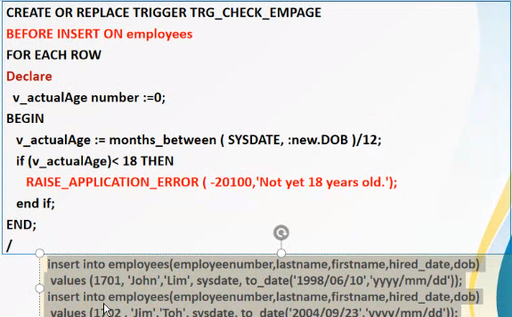
Note 2: A direct insert will cause a run-time error which can be avoided using a stored procedurwhich contains a compiler directive
PRAGMA EXCEPTION_INIT(exception_name, -Oracle_error_number); ]
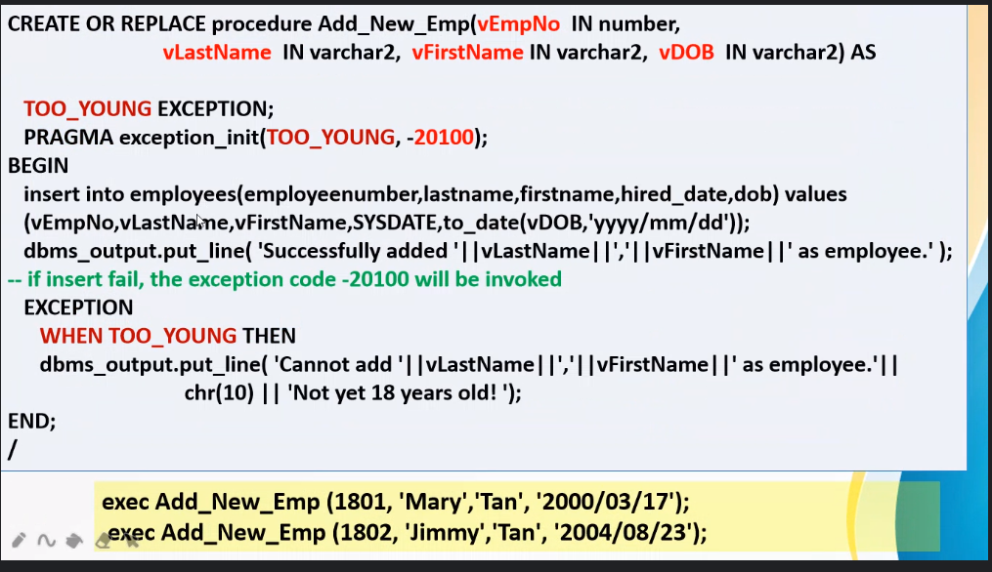
    - Add two more columns to the EMPLOYEES table, SALARY and SAL_GRADE. The SALARY column is the employee’s monthly pay and the SAL_GRADE column will indicate the employee’s salary grade. Create a lookup table to store the salary grade. Each salary grade will have a minimum and maximum salary amount. Create a trigger to ensure that an employee’s salary is always within the range of his/her salary grade. Test this trigger with a few UPDATE statements to the salary.

    - The records in ORDER_DETAILS table cannot be deleted. Create a trigger to ensure that all transactions are preserved.
(Do you need to create a trigger to protect the ORDERS records as well? Why or why not?)

    - Create a trigger that will display a warning message whenever an update on the credit limit of customers is performed on the last 3 days of a month.

